DSA06 - Data Handling and Visualization
Activity 8 : Identify_Seasonality
- No: 8 Reg. No: 192325043 Name: Bandaru Jahnavi

Series SP-C08: Electricity demand
The code given in the question was run unchanged to create x (n = 60 monthly values, January 2020 to December 2024). All figures below are the output of that R session.
Note on the formula: in R, writing 1:n inside a formula is read as an interaction term, and with n = 60 it fails with "variable lengths differ". I therefore wrote I(1:n) (the same as using t), which gives the intended regression on the observation number 1 to 60.

Task 1. Look at the series
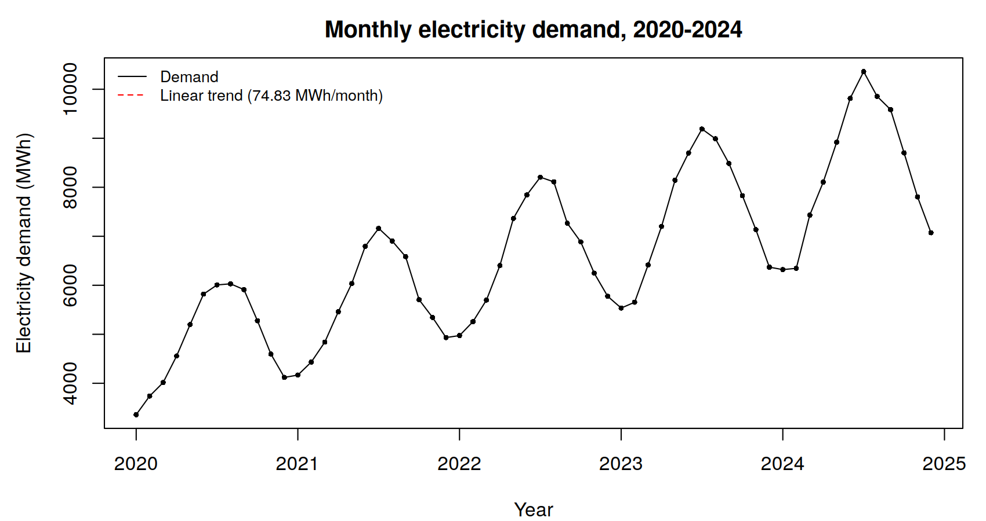
Item | Value
n | 60 observations
Cycle length | 12 observations (months)
Number of full cycles | 60 / 12 = 5 (2020, 2021, 2022, 2023, 2024)
Fitted line (lm(demand ~ I(1:n))) | demand = 4334.11 + 74.83 x month number
Slope per month | +74.83 MWh per month (standard error 7.86, t = 9.52, p = 1.9e-13)
Overall trend | Rising: about 74.83 x 12 = 898 MWh per year

The rise is also visible in the data: the average monthly demand of the first cycle is 4,885.8 MWh and of the last cycle 8,359.6 MWh, an increase of 71%. The plot shows a rising level with a regular up-and-down wave on top of it.

Task 2. The seasonal pattern
decompose(x)$figure gives the 12 seasonal values (additive type, the default):
Month | Seasonal (MWh) | Month | Seasonal (MWh) | Month | Seasonal (MWh)
Jan | -1392.05 | May | 668.13 | Sep | 736.86
Feb | -1303.49 | Jun | 1275.96 | Oct | 25.56
Mar | -708.33 | Jul | 1436.07 | Nov | -643.44
Apr | -86.02 | Aug | 1245.59 | Dec | -1254.84

- Peak month: July (month 7), seasonal value +1,436.07 MWh.
- Trough month: January (month 1), seasonal value -1,392.05 MWh.
- Seasonal swing = 1436.07 - (-1392.05) = 2,828.12 MWh.
Meaning: in a typical year July demand is about 1,436 MWh above the underlying level and January about 1,392 MWh below it. The 12 values add up to about zero, as they should.

Task 3. Is it consistent?
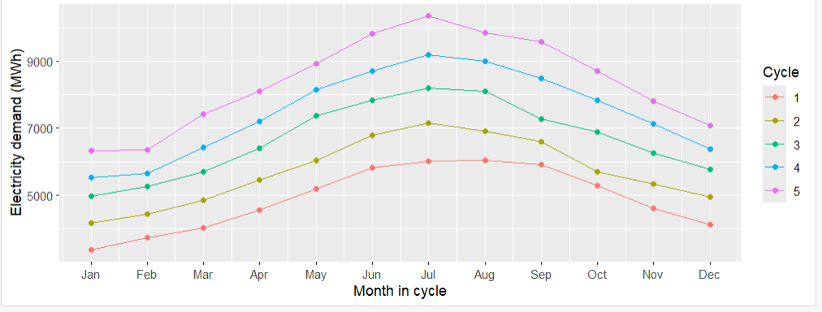
Cycle | Year | Month of highest value | Highest (MWh) | Month of lowest value | Lowest (MWh)
1 | 2020 | Aug | 6,030 (Jul 6,007) | Jan | 3,360
2 | 2021 | Jul | 7,162 | Jan | 4,168
3 | 2022 | Jul | 8,206 | Jan | 4,974
4 | 2023 | Jul | 9,189 | Jan | 5,535
5 | 2024 | Jul | 10,360 | Jan | 6,320

The highest value falls in the peak month (July) in 4 of the 5 cycles. In 2020 August (6,030) beats July (6,007) by only 23 MWh, which is well inside the random noise (standard deviation 135.7 MWh), and July is still the second highest. The lowest value is in January in all 5 cycles. The pattern is consistent: the five lines have the same shape, rise to a July peak and fall to a January trough, and are only shifted upwards from year to year by the trend.

Task 4. Confirm with autocorrelation [4 marks]
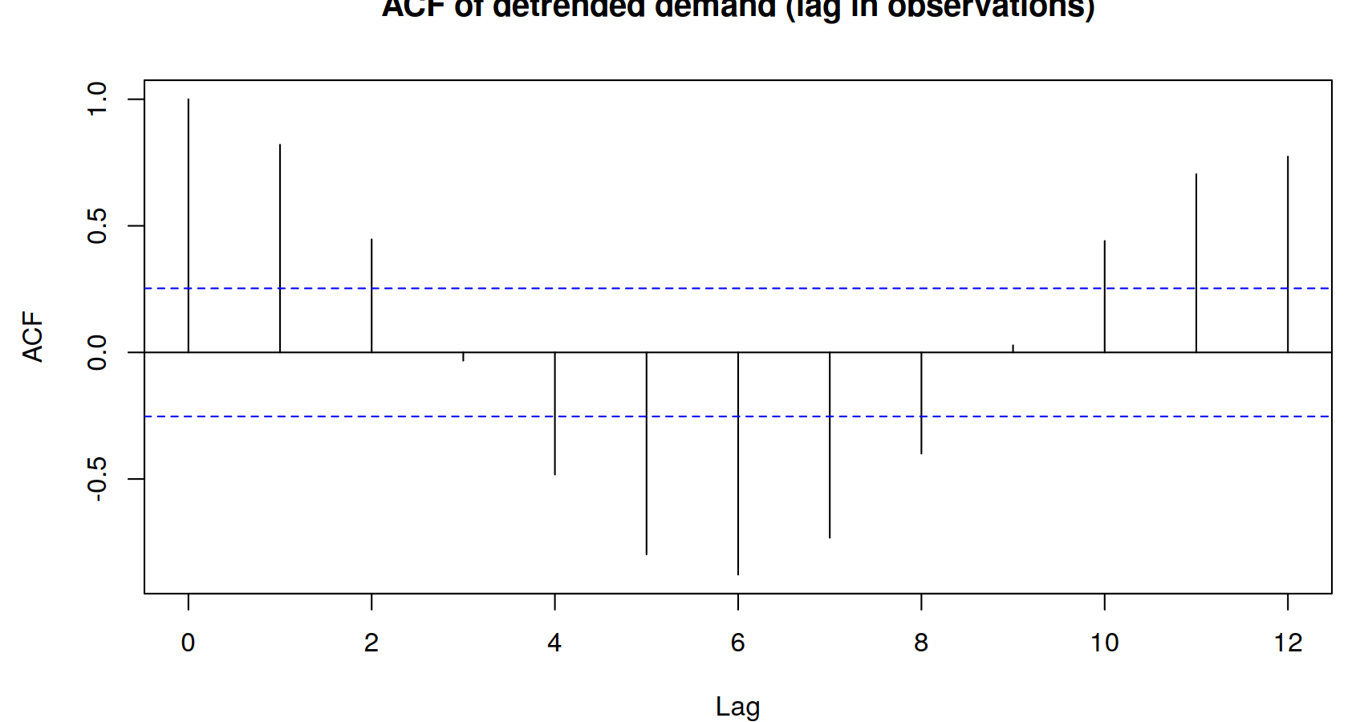
Lag | ACF | Lag | ACF | Lag | ACF | Lag | ACF
1 | 0.8202 | 4 | -0.4825 | 7 | -0.7321 | 10 | 0.4401
2 | 0.4465 | 5 | -0.7979 | 8 | -0.3996 | 11 | 0.7038
3 | -0.0326 | 6 | -0.8777 | 9 | 0.0281 | 12 | 0.7735

Quantity | Value | Compared with bound 2 / sqrt(60) = 0.2582
Autocorrelation at lag 12 | +0.7735 | Far above the bound (about 3.0 times as large)
Autocorrelation at lag 6 | -0.8777 | Far below -0.2582 (about 3.4 times as large in size)

What this says: both values are well outside the significance bound, so the pattern is real, not noise. The strongly positive lag-12 value means that observations one full cycle apart (the same month in different years) move together: the series repeats every 12 months. The strongly negative lag-6 value means that observations half a cycle apart (for example July and January) lie on opposite sides of the trend, one high and one low. Together, positive at the cycle length and negative at half the cycle length, they are the signature of a seasonal pattern with period 12. (The lag-12 value is below 1 because only 48 pairs are available and the ACF estimate shrinks with lag.)

Task 5. Additive or multiplicative? [6 marks]

Range in the first and last cycle [2]
Cycle | Max - min | Range
First (2020) | 6,030 - 3,360 | 2,670 MWh
Last (2024) | 10,360 - 6,320 | 4,040 MWh
Ratio last / first | 4,040 / 2,670 | 1.51

The swing grew by about 51% over the same period in which the level (cycle mean) grew from 4,885.8 to 8,359.6 MWh, a factor of 1.71. The range is about 55% of the mean in the first cycle (2,670 / 4,885.8) and 48% in the last (4,040 / 8,359.6), roughly a constant share. Decision: multiplicative. If the season were additive, the swing would stay about the same size (ratio near 1); instead it grows as the level grows, so the seasonal effect is a percentage of the level.
Multiplicative seasonal indices from decompose(x, type = "multiplicative")$figure:
Month | Index | Month | Index | Month | Index | Month | Index
Jan | 0.7885 | Apr | 0.9857 | Jul | 1.2295 | Oct | 1.0022
Feb | 0.8067 | May | 1.0946 | Aug | 1.1976 | Nov | 0.8972
Mar | 0.8927 | Jun | 1.1813 | Sep | 1.1185 | Dec | 0.8054

July is about 23% above the trend level (index 1.2295) and January about 21% below it (index 0.7885).

Seasonally adjusted slope [2]
adjusted <- x / decompose(x, type = "multiplicative")$seasonal, then lm(adjusted ~ I(1:n)) gives: intercept 4,384.64 and slope = +72.92 MWh per month. This is close to the raw slope of 74.83 (which was slightly inflated by the seasonal pattern within the five years) and shows that the underlying growth is steady at about 73 MWh a month, about 875 MWh a year.

Advice to management [2]
Management is right that demand follows a repeating 12-month pattern (peak in July, trough in January, autocorrelation +0.77 at lag 12), sitting on a steady rise of about 73 MWh per month, and because the swing grows with the level (multiplicative, July about 1.23 and January about 0.79 times the trend), capacity and purchasing for each July should be planned as a percentage uplift on the rising trend rather than as a fixed number of MWh.

R code used
set.seed(6424)
m <- 12; n <- m * 5; t <- 1:n
trend <- 4410.3 + 71.721 * t
demand <- round(trend * (1 + 0.22 * cos(2 * pi * (t - 7) / m)) + rnorm(n, 0, 135.7), 0)
x <- ts(demand, frequency = m, start = c(2020, 1))
# Task 1
plot(x); fit <- lm(demand ~ I(1:n)); coef(fit)
# Task 2
dc <- decompose(x); round(dc$figure, 2)
which.max(dc$figure); which.min(dc$figure); diff(range(dc$figure))
# Task 3 (ggplot2)
library(ggplot2)
df <- data.frame(demand = as.numeric(x), cycle = factor(rep(1:5, each = 12)),
pos = as.numeric(cycle(x)))
ggplot(df, aes(pos, demand, group = cycle, colour = cycle)) +
geom_line() + geom_point() +
scale_x_continuous(breaks = 1:12, labels = month.abb) +
labs(x = "Month in cycle", y = "Electricity demand (MWh)", colour = "Cycle")
tapply(df$demand, df$cycle, which.max) # position of the highest value
# Task 4
d <- resid(lm(demand ~ I(1:n)))
a <- acf(d, lag.max = 12, plot = FALSE); a$acf[c(7, 13)]; 2 / sqrt(n)
# Task 5
diff(range(demand[1:12])); diff(range(demand[49:60]))
dm <- decompose(x, type = "multiplicative")
adjusted <- x / dm$seasonal
coef(lm(as.numeric(adjusted) ~ I(1:n)))

